Mehmet Izol

Professor Cleveland

COMP 3324-1 Computer Networks

Week 4 – Lab 3 – Web of Trust

February, 28, 2023

Web of trust(WOT)

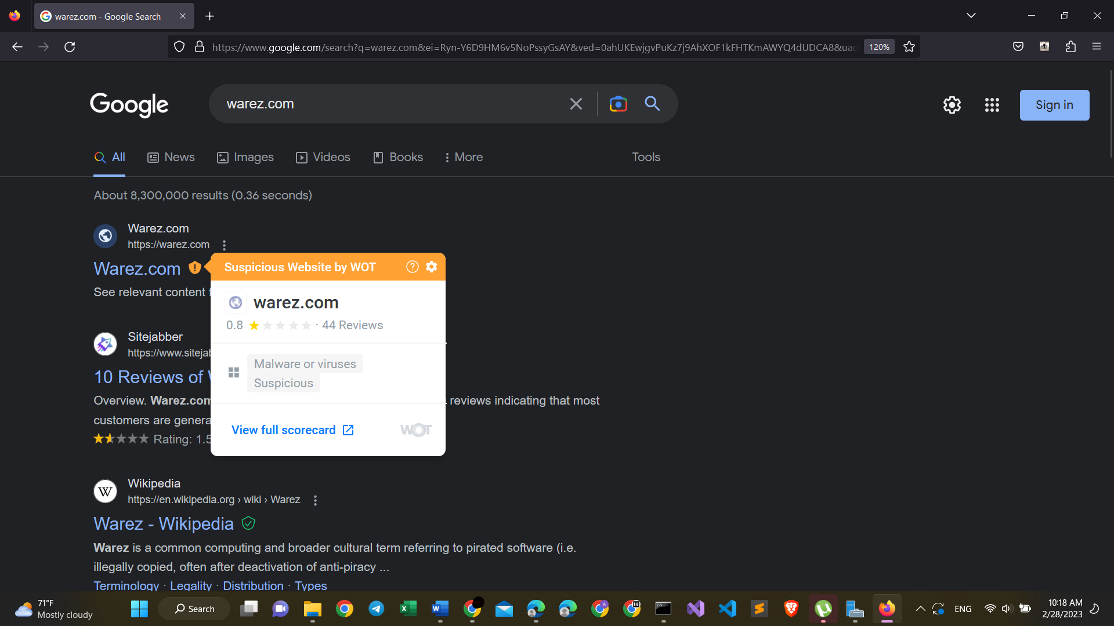

WOT extension shows which sites are safe and which are not sate.

Here we see that warez.com is very suspicious, and Wikipedia for instance is safe (has a green tick).